**BANK LOAN REPORT QUERY DOCUMENT**

1. **BANK LOAN REPORT | SUMMARY**

**KPI’s**

**Total loan Applications**

**Select count(id) as Total_loan_Applications from financial_loan;**



**Month to Date** **loan Applications**

**select count(id) as MTD_Total_loan_Applications from financial_loan where month(issue_date) = 12 and year(issue_date) = 2021;**



**Previous Month to Date** **loan Applications**

**select count(id) as PMTD_Total_loan_Applications from financial_loan where month(issue_date) = 11 and year(issue_date) = 2021;**



**Total Funded Amount**

**select sum(loan_amount) as MTD_loan_Amount from financial_loan;**



**Month to Date Total Funded Amount**

**select sum(loan_amount) as MTD_loan_Amount from financial_loan where month(issue_date) = 12 and year(issue_date) = 2021;**



**Previous Month to Date Total Funded Amount**

**select sum(loan_amount) as PMTD_loan_Amount from financial_loanwhere month(issue_date) = 11 and year(issue_date) = 2021;**



**Total Amount Received**

**select sum(total_payment) as Total_Amount_received from financial_loan;**



**Month to Date Total Amount Received**

**select sum(total_payment) as MTD_Total_Amount_received from financial_loan where month(issue_date) = 12 and year(issue_date) = 2021;**



**Previous Month to Date Total Amount Received**

**Select sum(total_payment) as PMTD_Total_Amount_received from financial_loan where month(issue_date) = 11 and year(issue_date) = 2021;**



**Average Interest Rate**

**Select avg(int_rate) * 100 as Avg_interest_Rate from financial_loan;**



**Month To Date Average Interest**

**Select avg(int_rate) * 100 as MTD_ Avg_interest_Rate from financial_loan where month(issue_date) = 12 and year(issue_date) = 2021;**



**Previous Month to Date Average Interest**

**Select avg(int_rate) * 100 as PMTD_Avg_interest_Rate from financial_loan where month(issue_date) = 11 and year(issue_date) = 2021;**



**Average DTI**

**Select avg(dti) * 100 as Avg_DTI from financial_loan;**



**Month to Date Average DTI**

**Select avg(dti) * 100 as Avg_DTI from financial_loan where month(issue_date) = 12 and year(issue_date) = 2021;**



**Previous Month to Date Average DTI**

**Select avg(dti) * 100 as Avg_DTI from financial_loan where month(issue_date) = 11 and year(issue_date) = 2021;**



**GOOD LOAN ISSUED**

**Good Loan Percentage**

**Select (count(case when loan_status = 'Fully Paid' or loan_status = 'current' then id end) * 100 )**

**/**

**count(id) as Good_loan_percentage from financial_loan;**



**Good Loan Applications**

**Select count(id) from financial_loan where loan_status = 'Fully Paid' Or loan_status = 'Current';**



**Good Loan Funded Amount**

**Select sum(loan_amount) As Good_loan_funded_amount from financial_loan where loan_status = 'Fully Paid' Or loan_status = 'Current';**



**Good Loan Amount Received**

**Select sum(total_payment) as Good_loan_total_received_ammount from financial_loan where loan_status = 'Fully Paid' Or loan_status = 'Current';**



**BAD LOAN ISSUED**

**Bad Loan Percentage**

**select (count(case when loan_status = 'Charged off' then id end) * 100 ) /**

**count(id) as Bad_loan_percentage**

**from financial_loan;**



**Bad Loan Applications**

**Select count(id) as Bad_loan_Applications from financial_loan**

**where loan_status = 'Charged off';**



**Bad loan funded Amount**

**Select sum(loan_amount) as Bad_loan_funded_ammount from financial_loan**

**where loan_status = 'Charged off';**



**Bad Loan Amount Received**

**Select sum(total_payment) as Bad_loan_ammount_received from financial_loan where loan_status = 'Charged off';**



**LOAN STATUS**

**Select loan_status,**

**count(id) as Total_loan_Applications,**

**sum(loan_amount) as Total_amount_Received,**

**sum(Total_payment) as Total_Funded_Amount,**

**avg(int_rate) as Interest_Rate,**

**avg(dti) as DTI**

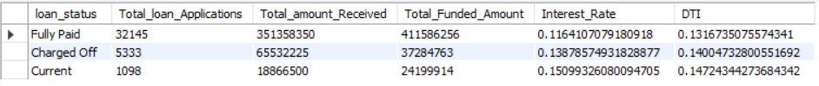**from financial_loan group by loan_status;**

**Select loan_status,**

**sum(total_payment) as MTD_Total_Amount_Received,**

**sum(loan_amount) as MTD_Total_Funded_Amount**

**from financial_loan where month(issue_date) = 12**

**group by loan_status;**

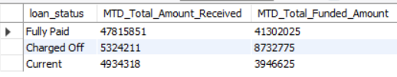

1. **BANK LOAN REPORT | OVERVIEW**

**MONTH**

**Select month(issue_date) as Month_Number,**

**monthname(issue_date) As Month_Name,**

**count(id) as Total_Loan_Applications,**

**sum(loan_amount) as Total_amount_Received,**

**sum(Total_payment) as Total_Funded_Amount**

**from financial_loan**

**group by month(issue_date), monthname(issue_date)**

**order by month(issue_date);**

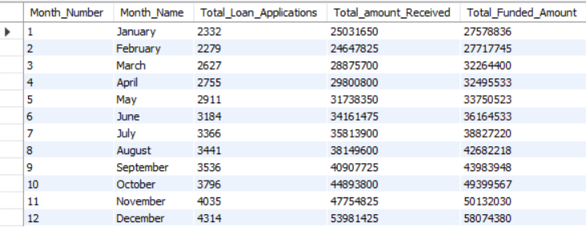

**STATE**

**Select address_state as States,**

**count(id) as Total_Loan_Applications,**

**sum(loan_amount) as Total_amount_Received,**

**sum(Total_payment) as Total_Funded_Amount**

**from financial_loan**

**group by address_state**

**order by address_state;**

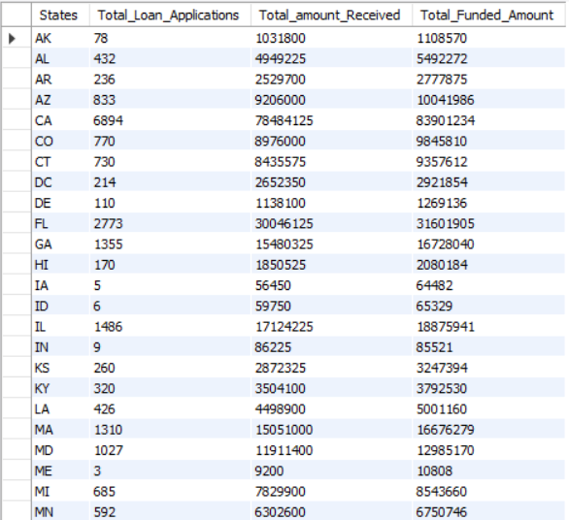

**TERM**

**Select Term,**

**count(id) as Total_Loan_Applications,**

**sum(loan_amount) as Total_amount_Received,**

**sum(Total_payment) as Total_Funded_Amount**

**from financial_loan**

**group by term**

**order by term;**

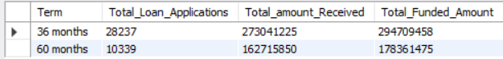

**EMPLOYEE LENGTH**

**Select Emp_length,**

**count(id) as Total_Loan_Applications,**

**sum(loan_amount) as Total_amount_Received,**

**sum(Total_payment) as Total_Funded_Amount**

**from financial_loan**

**group by Emp_length**

**order by Emp_length;**

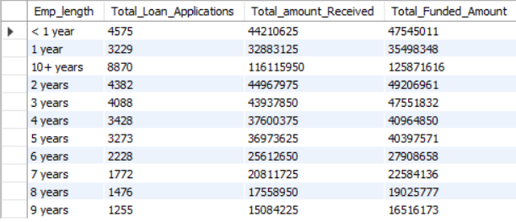

**PURPOSE**

**Select Purpose as Loan_Purpose,**

**count(id) as Total_Loan_Applications,**

**sum(loan_amount) as Total_amount_Received,**

**sum(Total_payment) as Total_Funded_Amount**

**from financial_loan**

**group by Purpose**

**order by count(id) desc;**

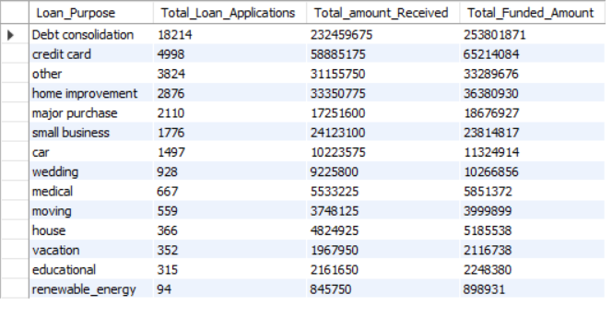

**HOME OWNERSHIP**

**Select Home_ownership,**

**count(id) as Total_Loan_Applications,**

**sum(loan_amount) as Total_amount_Received,**

**sum(Total_payment) as Total_Funded_Amount**

**from financial_loan**

**group by Home_ownership**

**order by count(id) desc;**

